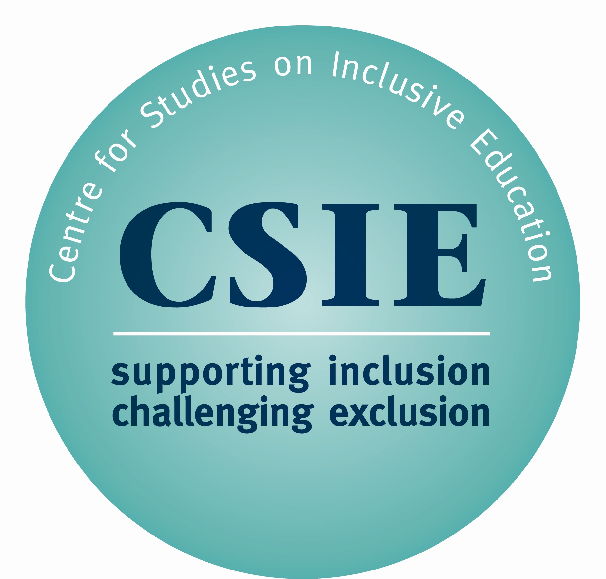

ROYALTIES DUE FROM TRANSLATIONS OF CSIE RESOURCES
March 2023

1. The publication
Title of original | Index for Inclusion: developing learning and participation in schools
Translated in: (language)
Available in: (country)
Date translation first published:
Initial print run:

2. Main contact details
Name (as this appears in contract with CSIE)
Title (as this appears in contract with CSIE)
Email address (as this appears in contract with CSIE)
If there is a change in main contact details, please print new name, title and email address

3. Royalties paid
Date of last royalty payment to CSIE:
Amount of last royalty payment to CSIE:
Period covered by last payment:

4. Royalties due for period ending 30 September 2018
Number of additional copies printed, since last payment:
Number of copies sold since last payment:
Unit price:
Total selling price:
Royalty payment due to CSIE:
(10% of total selling price)

Please ensure that your payment, in sterling, reaches CSIE by 31 October 2023.

Overseas Bank Details for CSIE:

IBAN No: GB51CAFB40524000018312
Account No: 00018312
Sort Code: 40-52-40
SWIFT/BIC Code: CAFBGB21XXX

Please let CSIE know if you need an invoice and/or receipt for this payment. Thank you.

