Jonathan Shaw, MP
Minister for Disabled People
The House of Commons
London
SW1 OAA

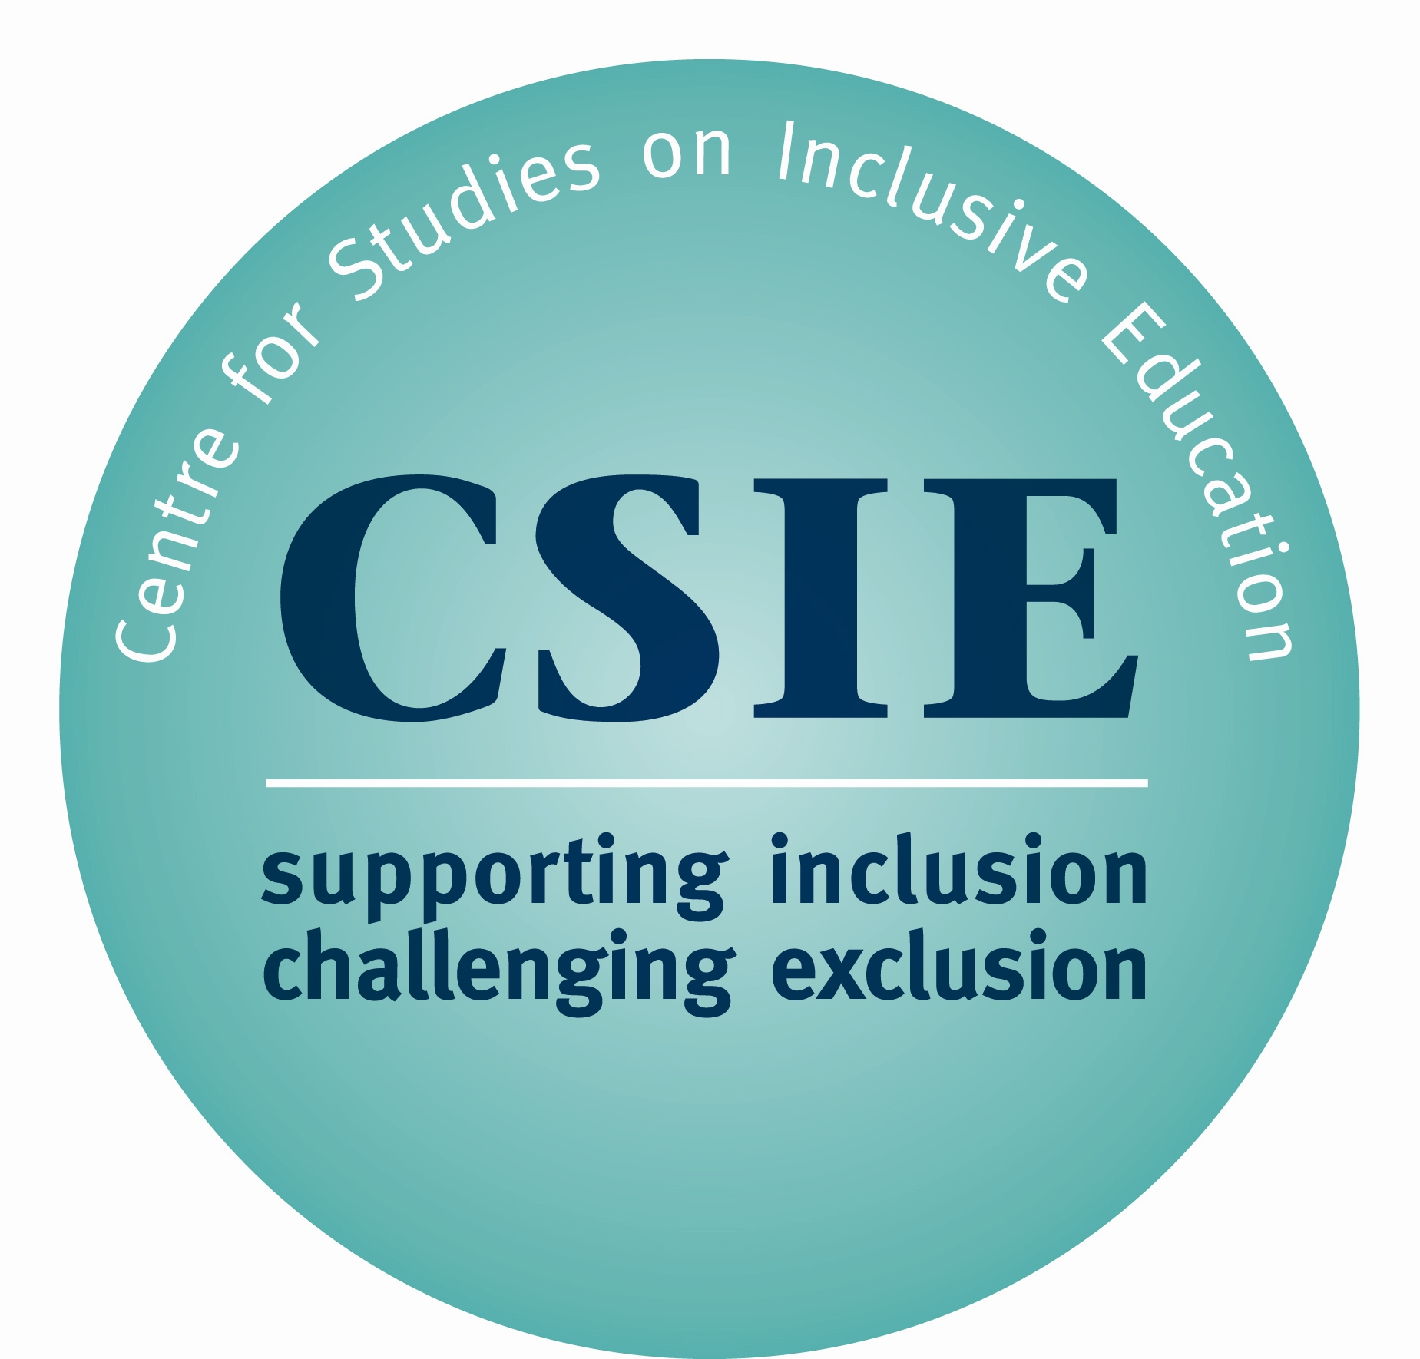

Monday 30 March 2009

Dear Minister,

We write with regard to the continuing controversy over the proposed reservation and interpretive declaration on Article 24 (Education) of the UN Convention on the Rights of Persons with Disabilities, particularly following the announcement by the Northern Ireland Human Rights Commission that "the proposed reservation and declaration (…) could hinder progress towards the inclusion of disabled children in mainstream education."

We note that the UK government has repeatedly declared its commitment to the development of inclusive education; for example in publicizing objectives to support “the development of inclusive practice in all schools and early years settings” (Removing Barriers to Achievement, 2004, p. 51) and the more recent launch of a National Strategy aiming to “help schools develop more inclusive practice” (Inclusion Development Programme, 2007, p. 2).

The Convention was intentionally designed to be aspirational and to allow for progressive realization. Reserving on areas where compliance is likely to take time would wrongly indicate that the UK is not expecting to make further progress towards inclusion. This would seriously undermine the UK's leading position in promoting disabled people's rights and could give rise to objections from foreign governments claiming that such reservations go against the spirit of the Convention and appear to be designed to maintain the status quo.

Your Explanatory Memorandum of 3 March 2009 to the House of Commons cites parental choice as a reason for registering a reservation on Article 24 and, therefore, allowing for the practice of segregated schooling to be perpetuated. This is not only unethical, by disregarding the right to education without discrimination, it is also unnecessary. If the DCSF’s commitment to parental choice extends to honouring the choice of parents seeking a mainstream place for their disabled child, surely the Department will be seeking to develop inclusive provision in every locality. Seeking to develop inclusive schools is consistent with para 2(b) of Article 24.

We hope the UK government will choose to be neither counterproductive, nor the object of scorn. Out of the 139 governments that have signed this Convention and the 50 that have so far ratified it, not one has expressed a reservation or an interpretive declaration on Article 24. Knowing that your personal intervention can be decisive, we look forward to hearing your response to the Northern Ireland Minister for Education, on her recommendation of full ratification of Article 24.

Yours sincerely

Artemi Sakellariadis Chris Goodey
Director Assistant Director

