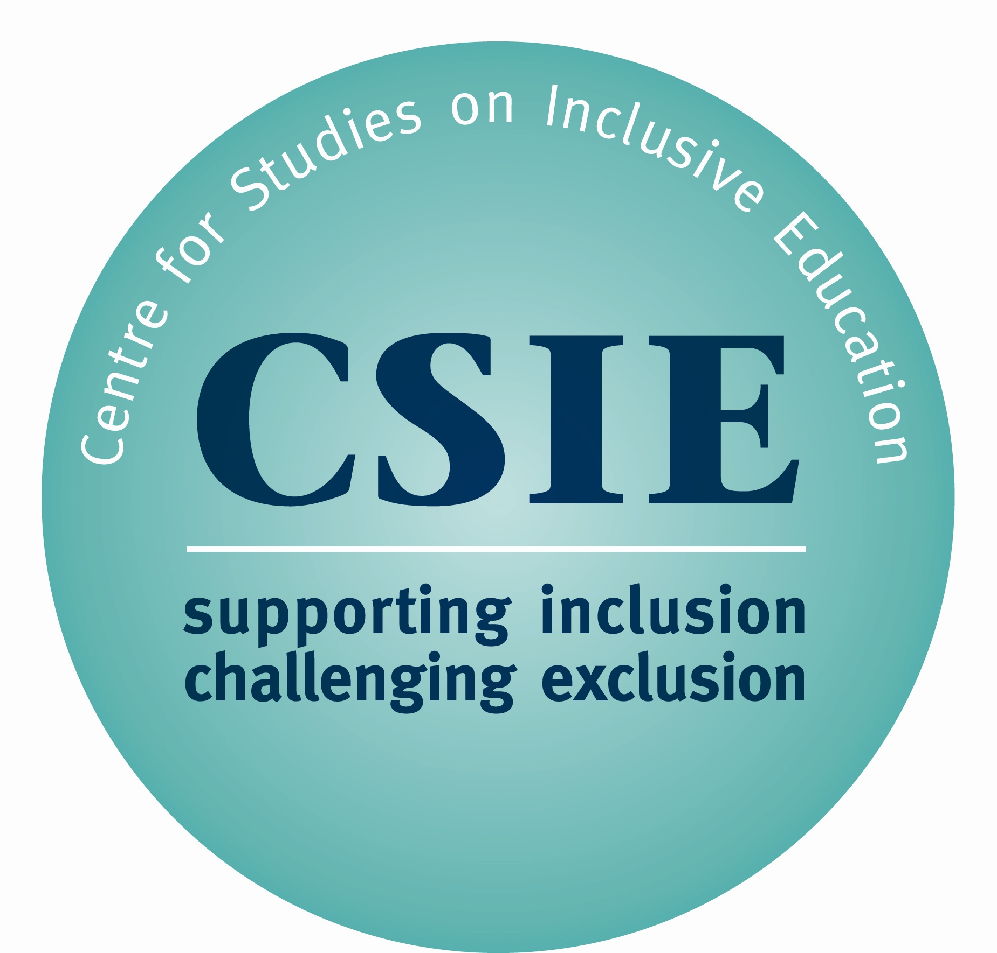 CSIE CONFERENCE

Is everyone welcome? Preventing rejection from 21st century schools.

Friends’ Meeting House, 6 Mount Street, Manchester M2 5NS
10:00 am – 4:30 pm, Tuesday 8th December
PROGRAMME

10:00 Arrival & registration

10:45 Welcome and introduction

11:00 The role of local authorities in the development of inclusive
education for all
Professor Mel Ainscow
University of Manchester

12:00 The Welcome Workbook
Chris Goodey, CSIE

12:30 Lunch

1:30 Developing inclusive education for all: the Hamilton
experience
Jackie Bajus and Laszlo Galambos
Hamilton-Wentworth Catholic District School Board, Canada

2:30 Workshops (please see below)

3:30 Tea

3:45 Plenary and thoughts on next steps

4:30 Conference ends

Delegates will have a choice of five workshops:

1) Health Services and Schools
What can I do in my local area to give Child Health Services a stronger presence in mainstream schools?

2) Transitions and Pathways
What can I do in my local area to ensure that young people leave school or college prepared for an ordinary life in the community?

3) Perceptions of disability
What can I do in my local area to overcome attitudinal barriers to inclusive schooling for all?

4) Expertise and confidence
What can I do in my local area to ensure that mainstream school staff feel confident to include all learners?

5) Effective collaboration
What can I do to ensure that my local authority uses its powers and responsibilities to enable schools to provide for the full diversity of learners?

